Onboarding Instructions at Anheuser Busch

Contents

Accessing & Signing on to MiDesktop. 1

Installing VIP Access 1

MiDesktop Logon and Installation 1

# Accessing & Signing on to MiDesktop.

## Installing VIP Access

1. Install VIP Access to your computer.

[https://idprotect.verisign.com/desktop/home.v](https://urldefense.proofpoint.com/v2/url?u=https-3A__idprotect.verisign.com_desktop_home.v&d=DQMFaQ&c=xbbKDa1CXQMejoORxEnUuQ&r=JNhscdCzB-2B_79TtvWaKAZ4E6ymlVaTNwsvZhWDGLabWcJRuoANLdM7EDB-GMLj&m=rRuNkZCv0Bmagq4hLnoSk18KL3jU6-IO9KYacNPk74E&s=DzYXpGLuy1za6AkxXIucv-xaMk2sPyKMExXpqmVg8ZY&e=)

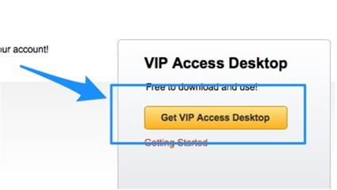

1. After you install you will see a little box with Credentials and a Code (Token)
2. Call 1-800-BEER-TALK…they will ask you for the Credentials (from above) and help you setup the Pin number

**BEER TALK authentication**

Favorite color: Blue

Favorite food: Chips

Favorite sport: Baseball

## MiDesktop Logon and Installation

1. Use that to pin + the token to login to:   <https://midesktop.anheuser-busch.com/vpn/index.html>
2. 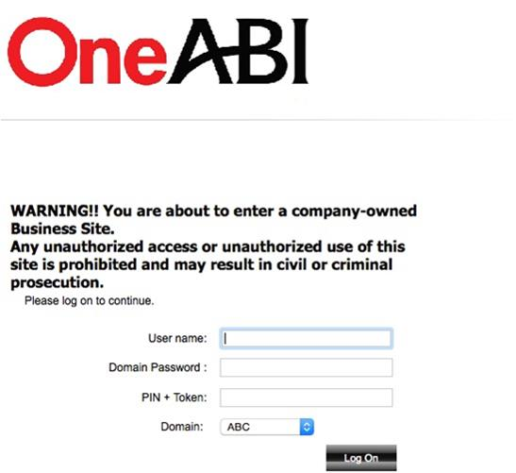
3. User name is your Y-ID, Domain Password is your Windows password. Use the new Pin and the Token Code and Log On